|  |  |  |  |  |
| --- | --- | --- | --- | --- |
| |  |  | | --- | --- | | Manual |  | |  |  | |
| Setup Docker Host (Ubuntu 16.04) |

# Prerequisite

|  |  |  |  |
| --- | --- | --- | --- |
| No | Description | Specification | Remark |
| 1 | OS Version | Ubuntu 16.04 |  |
| 2 | vCPU | 6 Units |  |
| 3 | Memory | 8 GB or Upper |  |
| 4 | Disk |  |  |

# Setup Ubuntu Step-by-Step

1. Insert ISO for start setup with “English Language” and continue (First Time: Initial disk on 15 GB)

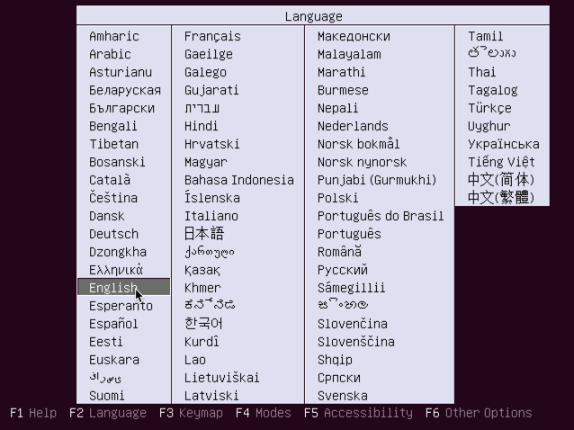

1. Select “Install Ubuntu Server” and continue

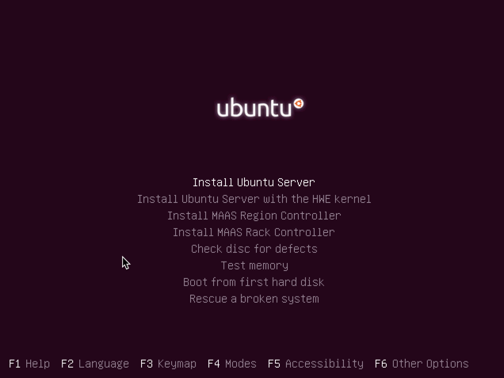

1. Choose language to “English”

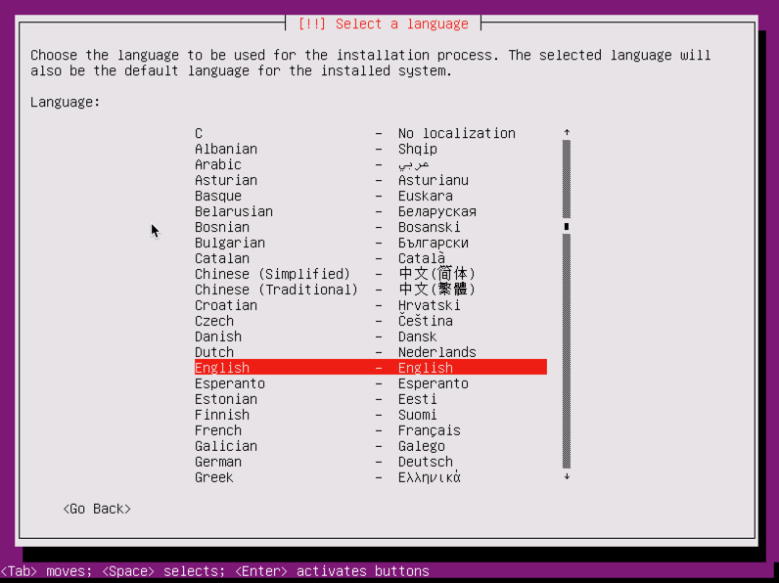

1. Select regional to “Other” 🡺 “Asia” 🡺 “Thailand”

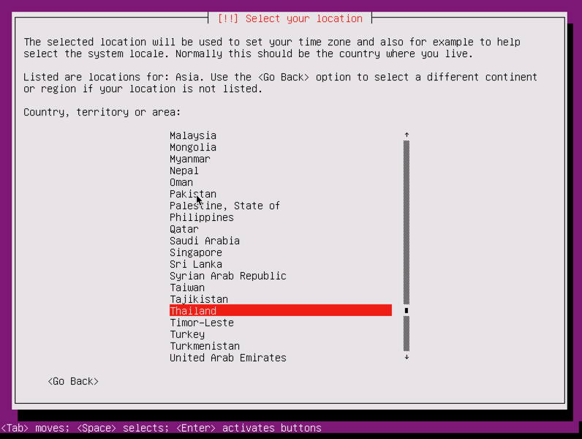

1. Select locales to “United States”

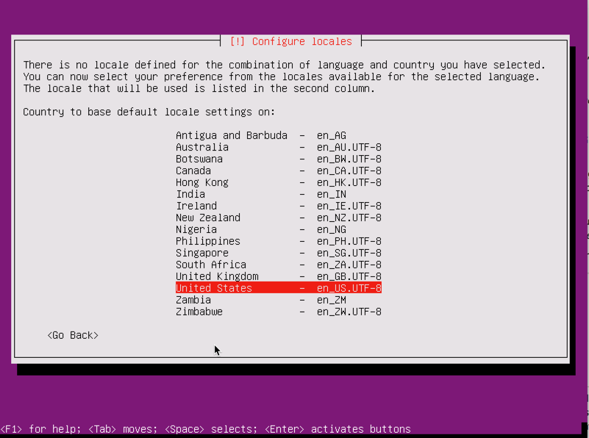

1. Select detect keyboard to “No” and Configure the keyboard to “English (US”

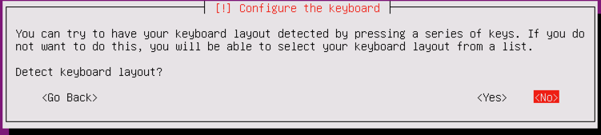

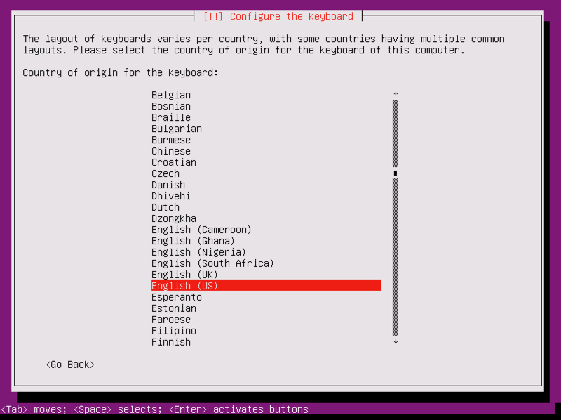

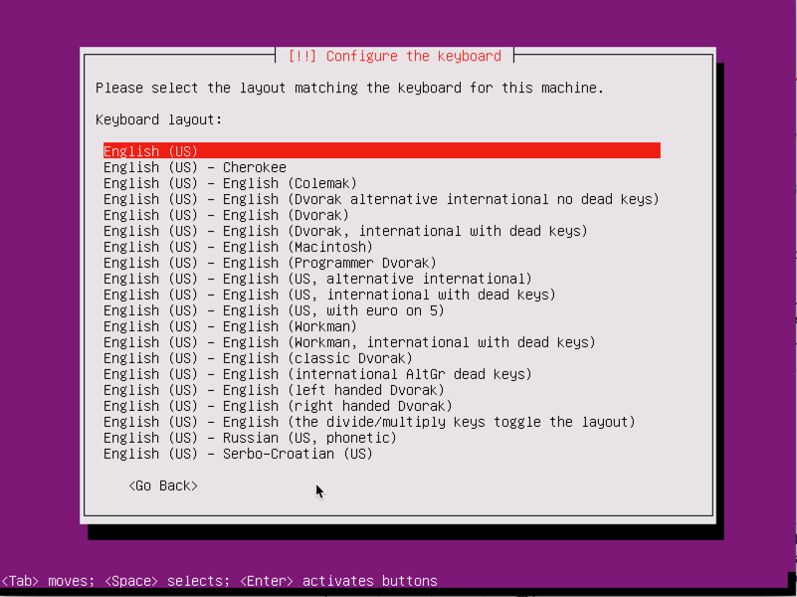

1. System will start to detect hardware for operate. Press “Cancel” when system try to detect DHCP for manual configure ip address

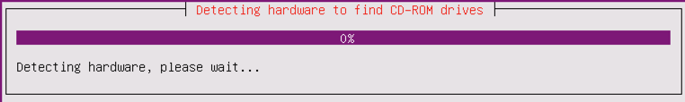

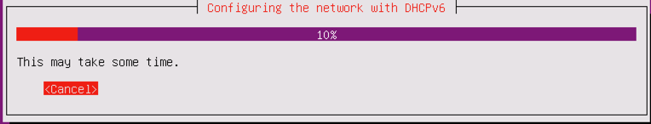

1. Setup machine detail as information below
   1. Hostname: dockerserve-dev-0001
   2. Pick a username: docker
   3. Choose a password: Hen9Le@$n9

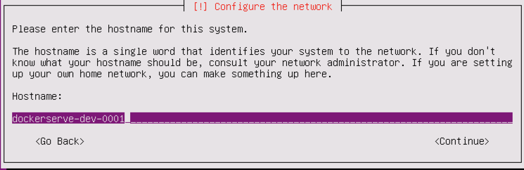

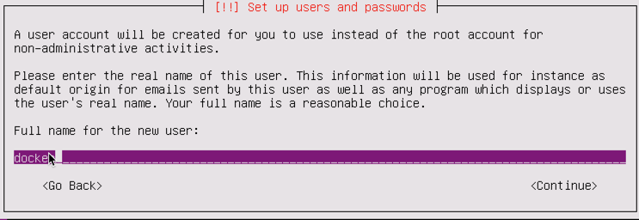

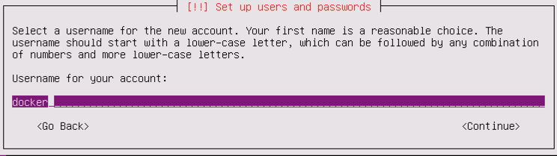

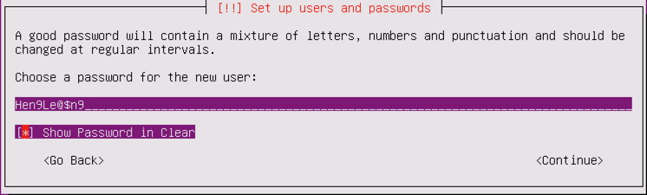

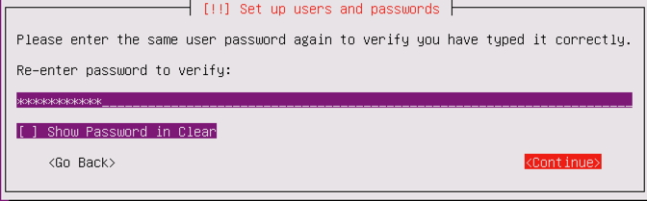

1. Select “No” for encrypt your home directory

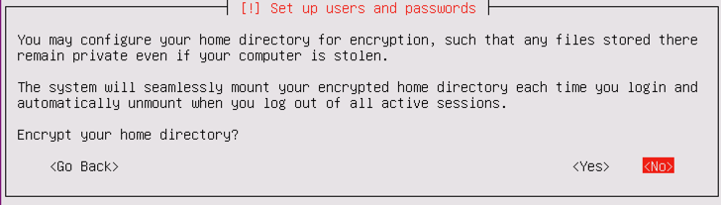

1. System will continue setup time. Accept for “Asia/Bangkok”

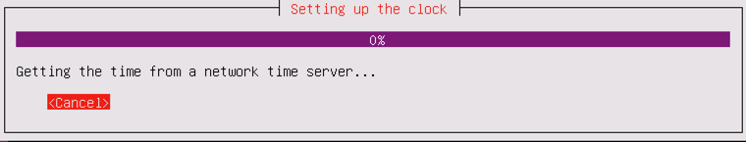

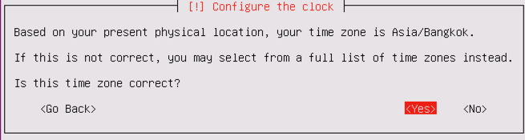

1. Click create “New Partition Table” as detail below

/ ==> <dockerserve--vg-v-root:15 GB>

/home ==> <dockerserve--vg-v-home:10 GB>

/var ==> <dockerserve--vg-v-var:35 GB>

/tmp ==> <dockerserve--vg-v-tmp: 10 GB>

/var/log ==> <dockerserve--vg-v-var_log:10 GB>

/swap ==> <dockerserve--vg-v-swap: 5 GB>

* 1. Select Manual for partition disks by LVM as step below

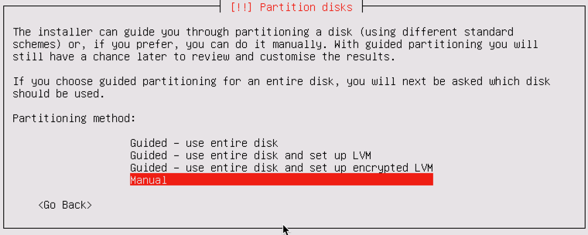

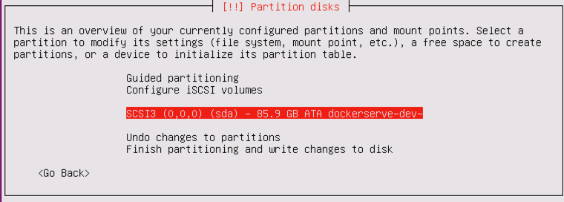

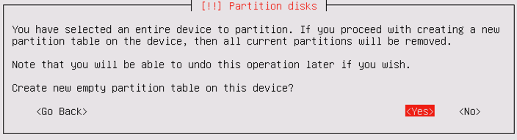

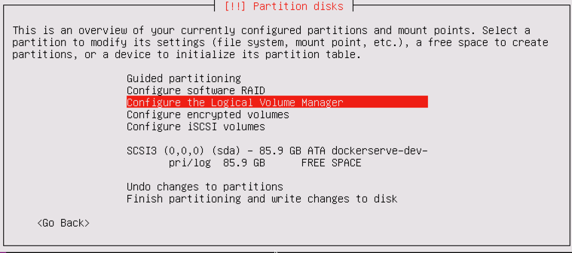

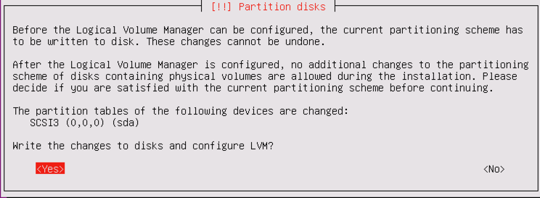

* 1. Create Physical Volumes (PV) by step below

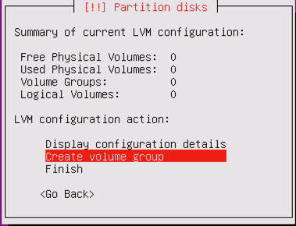

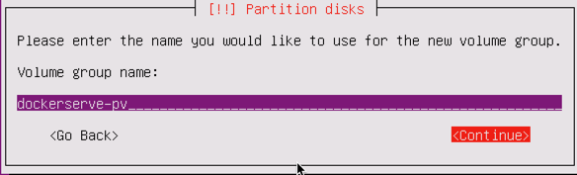

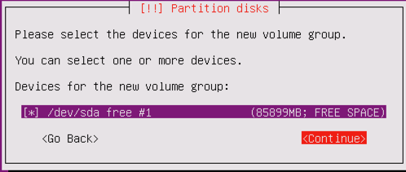

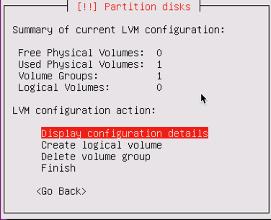

* 1. Create Logical Volume for “dockerserve--vg-v-root”

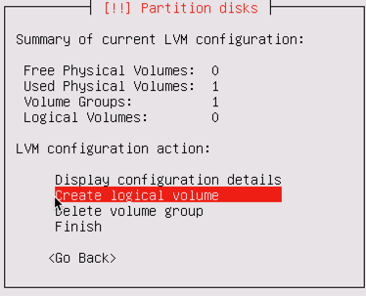

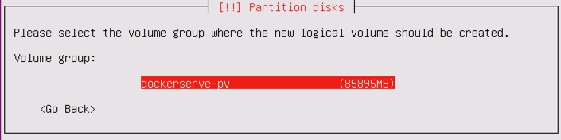

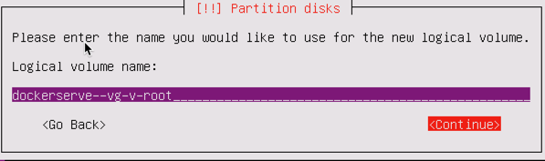

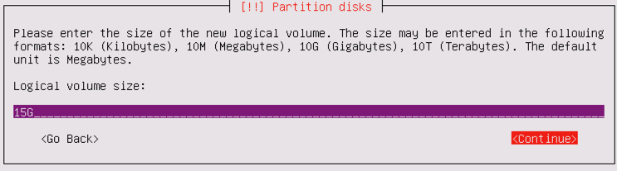

* 1. Repeat step for create Logical Volume for “dockerserve--vg-v-home”

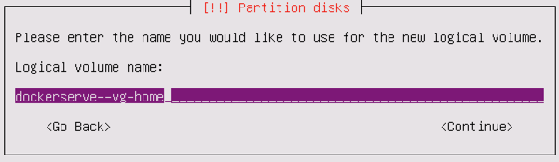 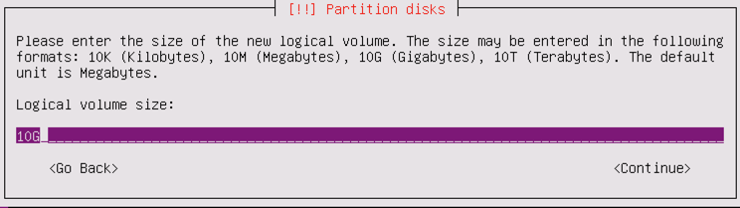

* 1. Repeat step for create Logical Volume for “dockerserve--vg-v-var”

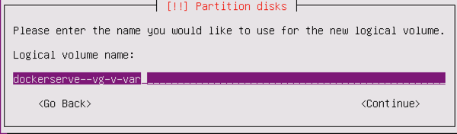 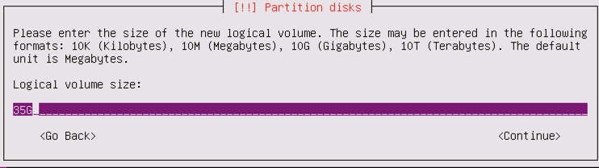

* 1. Repeat step for create Logical Volume for “dockerserve--vg-v-tmp”

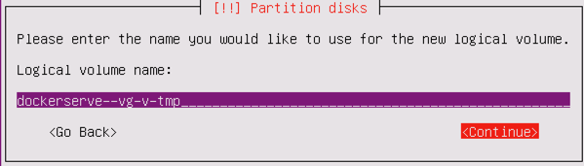 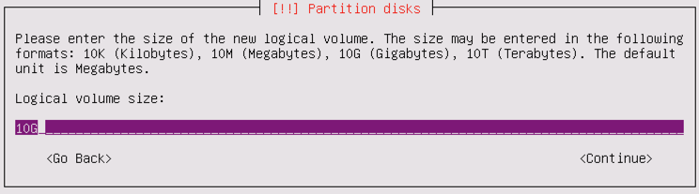

* 1. Repeat step for create Logical Volume for “dockerserve--vg-v-var_log”

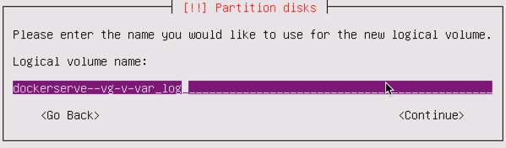 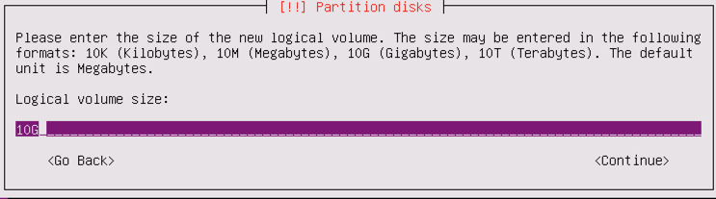

* 1. Repeat step for create Logical Volume for “dockerserve—vg-va-swap”

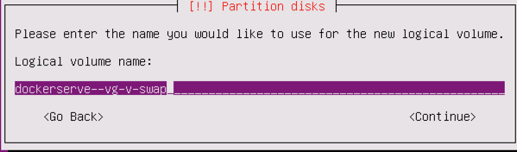 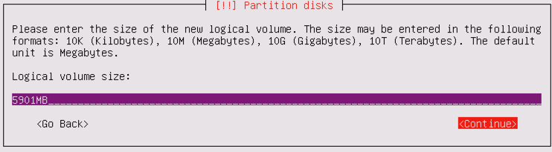

* 1. Review all partition information and “Finish”

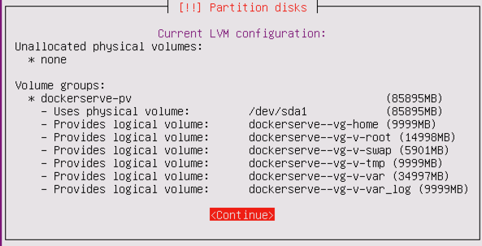

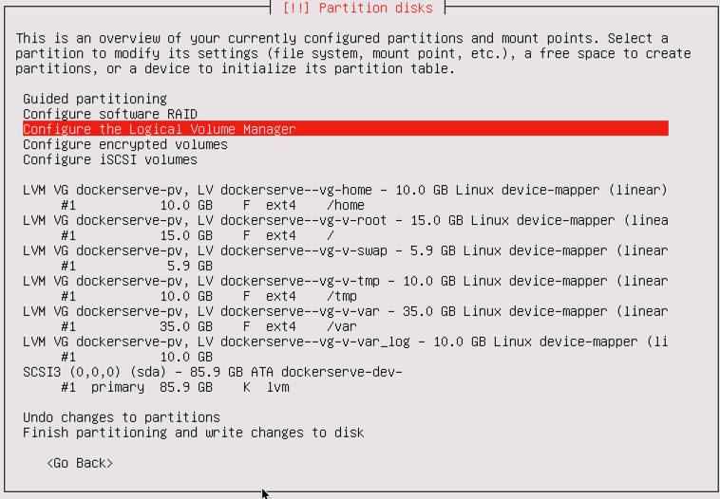

* 1. Set mount point for “dockerserve--vg-v-root”

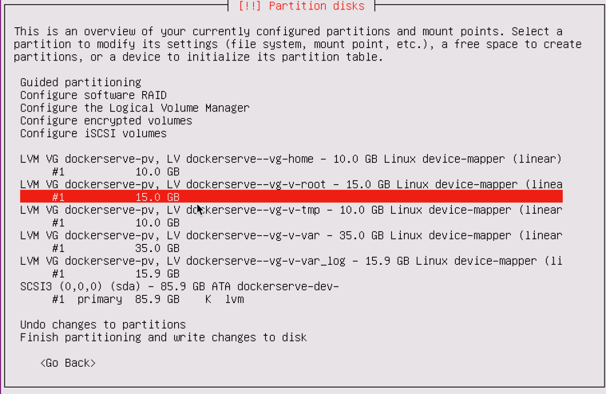 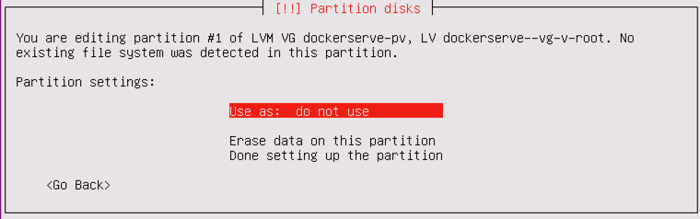

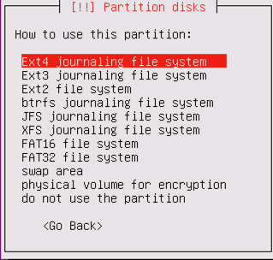 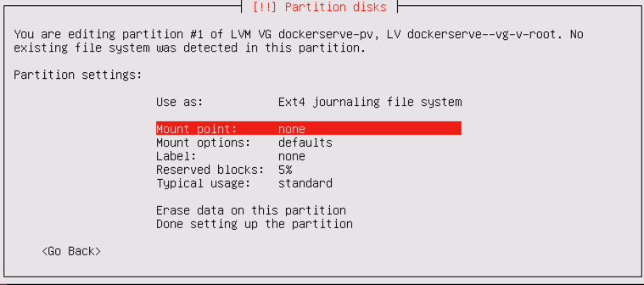

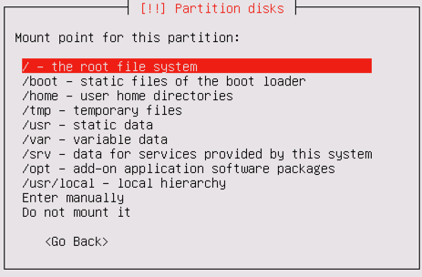 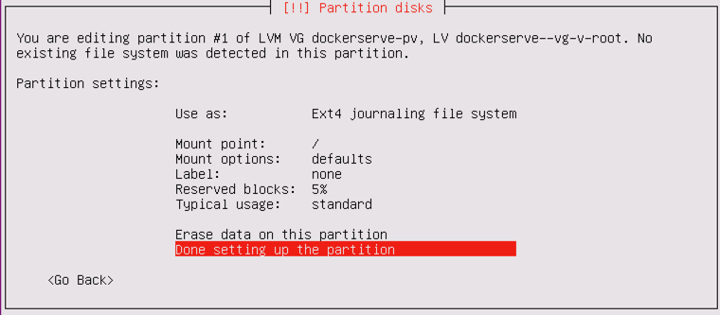

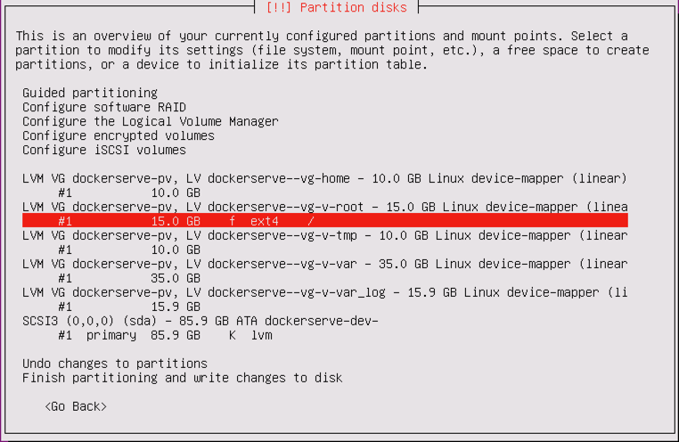

* 1. Set mount point for “dockerserve--vg-v-home”

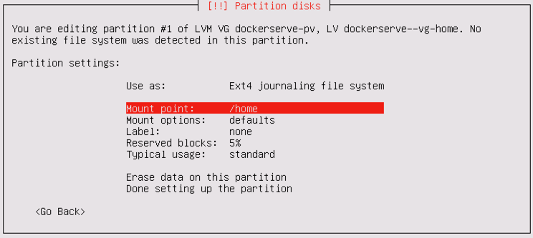

* 1. Set mount point for “dockerserve--vg-v-var”

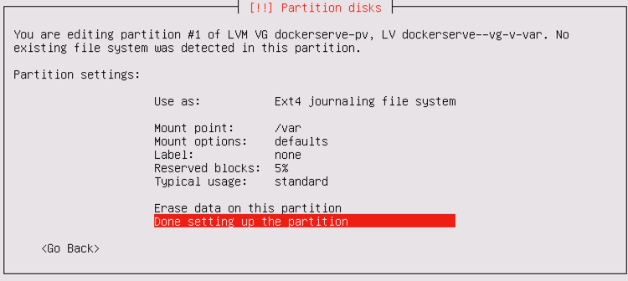

* 1. Set mount point for “dockerserve--vg-v-tmp”

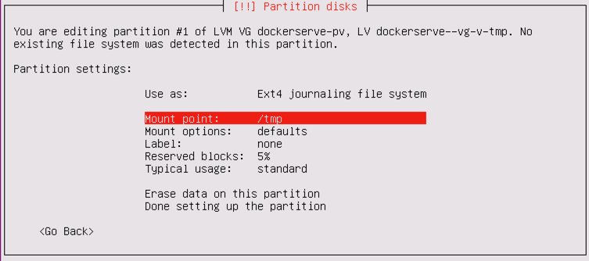

* 1. Set mount point for “dockerserve--vg-v-var_log”

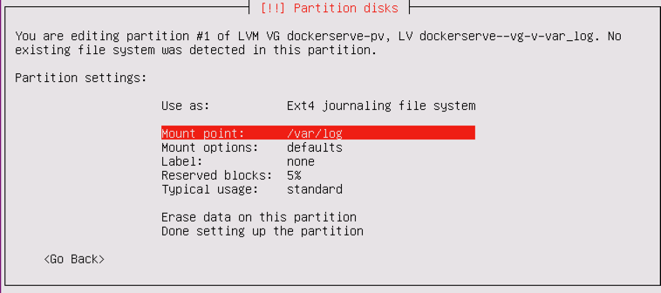

* 1. Set mount point for “dockerserve—vg-v-swap”

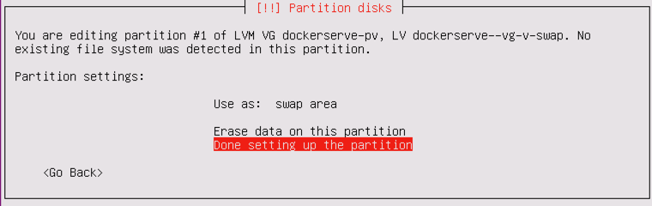

* 1. Finished partitioning and write changes to disk

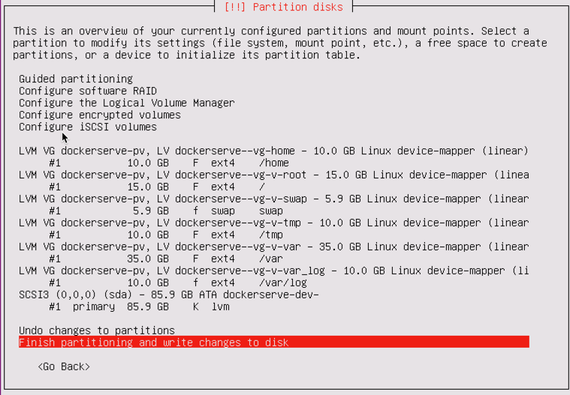

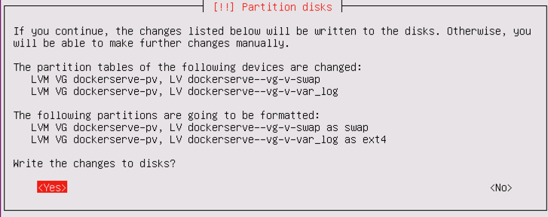

1. System will continute install OS



1. Leave blank for proxy setting

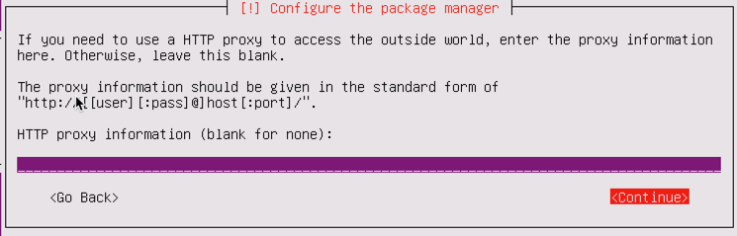

1. Wait until setup was done for apt component and disable automatic update

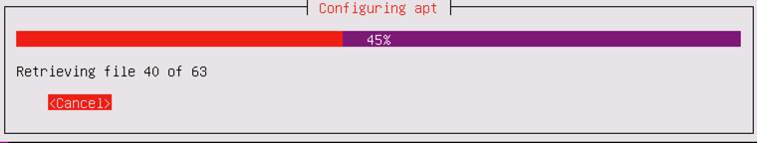

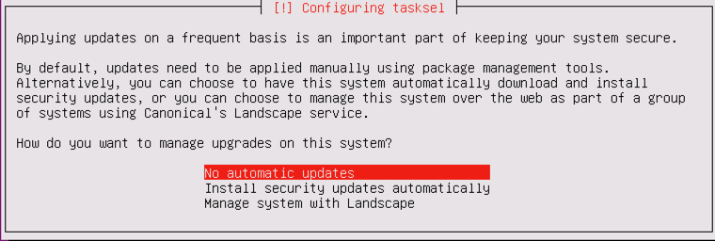

1. Setup openssh and continute

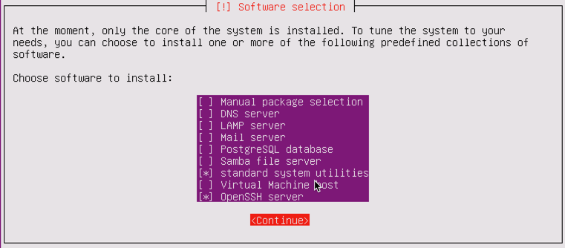

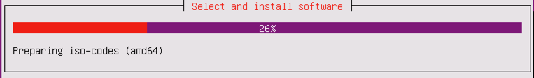

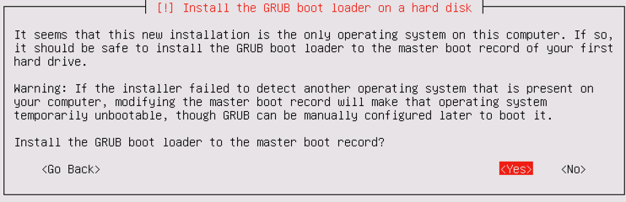

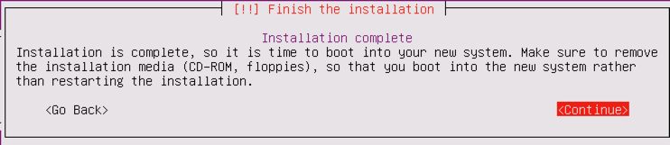

1. Edit file /usr/share/unattended-upgrades/unattended-upgrade-shutdown (Line 120) for fix bug pending =
   1. Before: if apt_pkg.config.find_b("Unattended-Upgrade::InstallOnShutdown", False)
   2. After: if apt_pkg.config.find_b("Unattended-Upgrade::InstallOnShutdown", false)

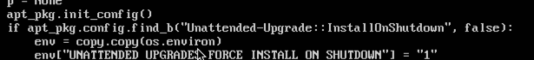

1. After reboot, Access shell and configure locate by command and Reboot:

sudo echo "LC_ALL=en_US.UTF-8" | sudo tee -a /etc/default/locale

sudo echo "LC_CTYPE=en_US.UTF-8" | sudo tee -a /etc/default/locale

